I have created the database as requested and stored procedure to get products by SKU. Used c# .NET core and sql server as a backend. Angular has been used for UI. All Products and categories have been displayed. Successfully managed to bring DB via stored procedure to get products by category. Didn't get around to displaying page for Product Range via SKU although you can see the result being pulled in the console screen shot attached.

PS: please follow instructions provided here for project setup <https://github.com/shikha2082/MMTShop/tree/main/MMTShopUI/MMTShopUI#readme>

Backend Jason by visual studio (.Net core):

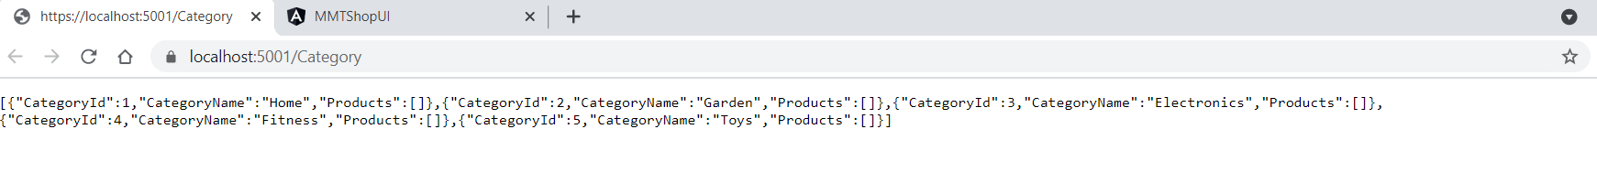

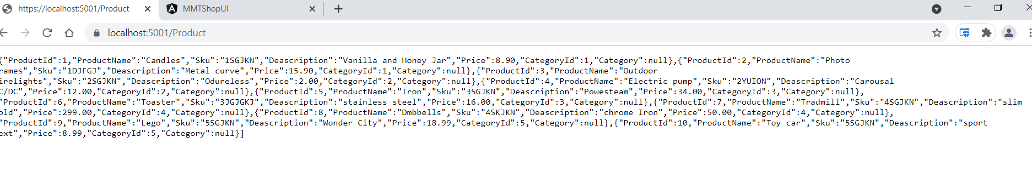

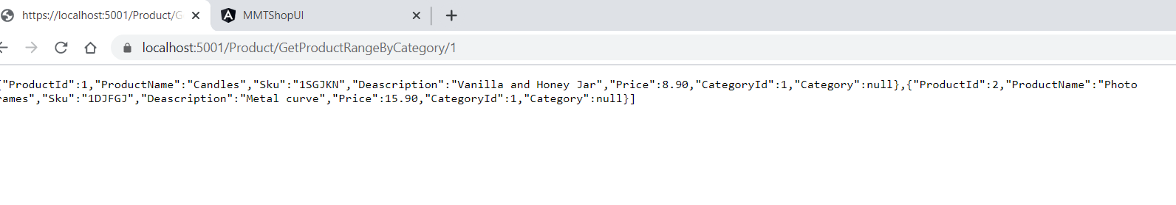

Angular UI pages:

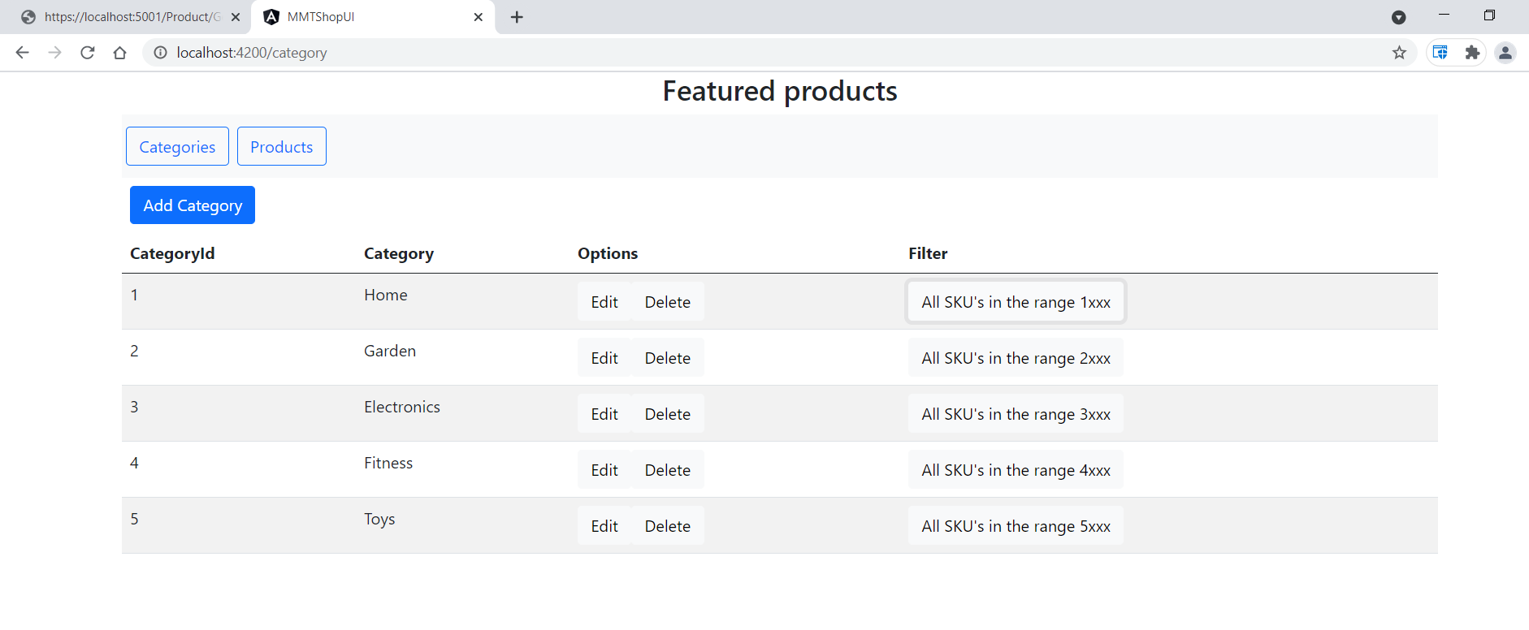

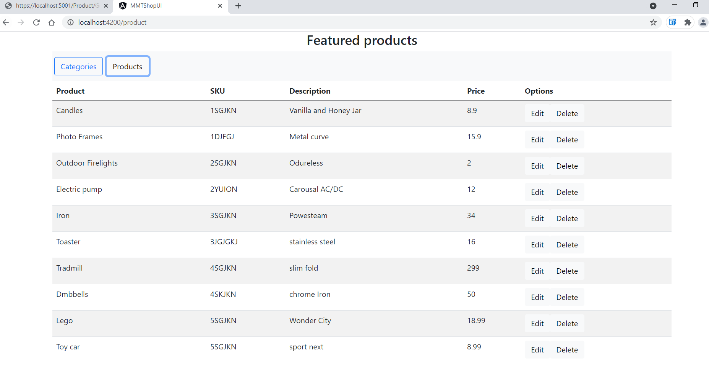

When All product range is clicked, the data is loaded correctly in the bottom grid as can be seen in console. 